press release

New X-System for CBRN Monitoring

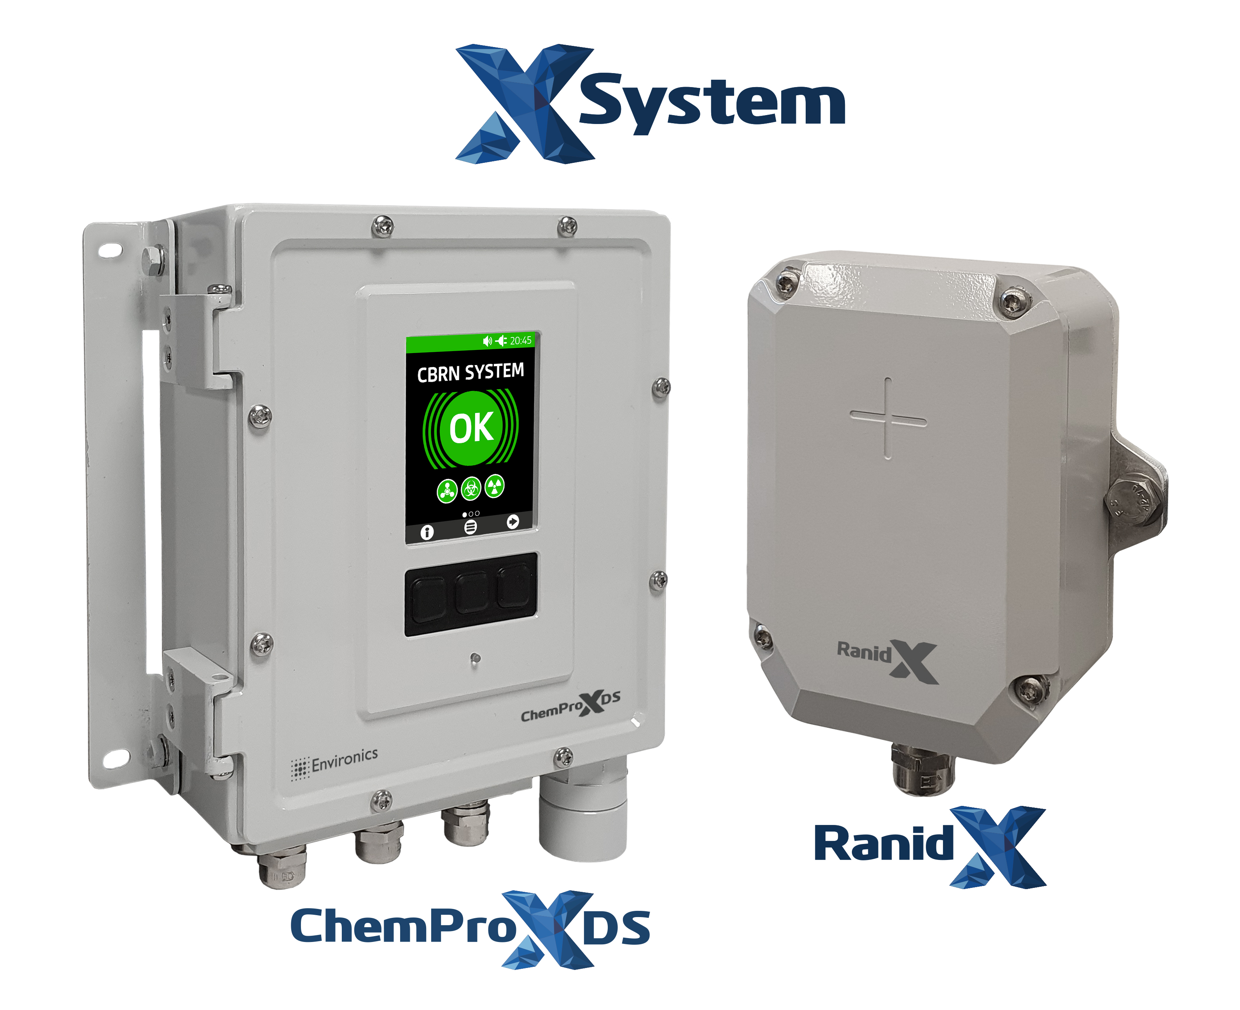
Picture 01 X-System new COTS components. On the left, ChemProX-DS — Detection System Compatible Chemical Detector — and on the right side, RanidX — Detection System Compatible Radiation Detector.

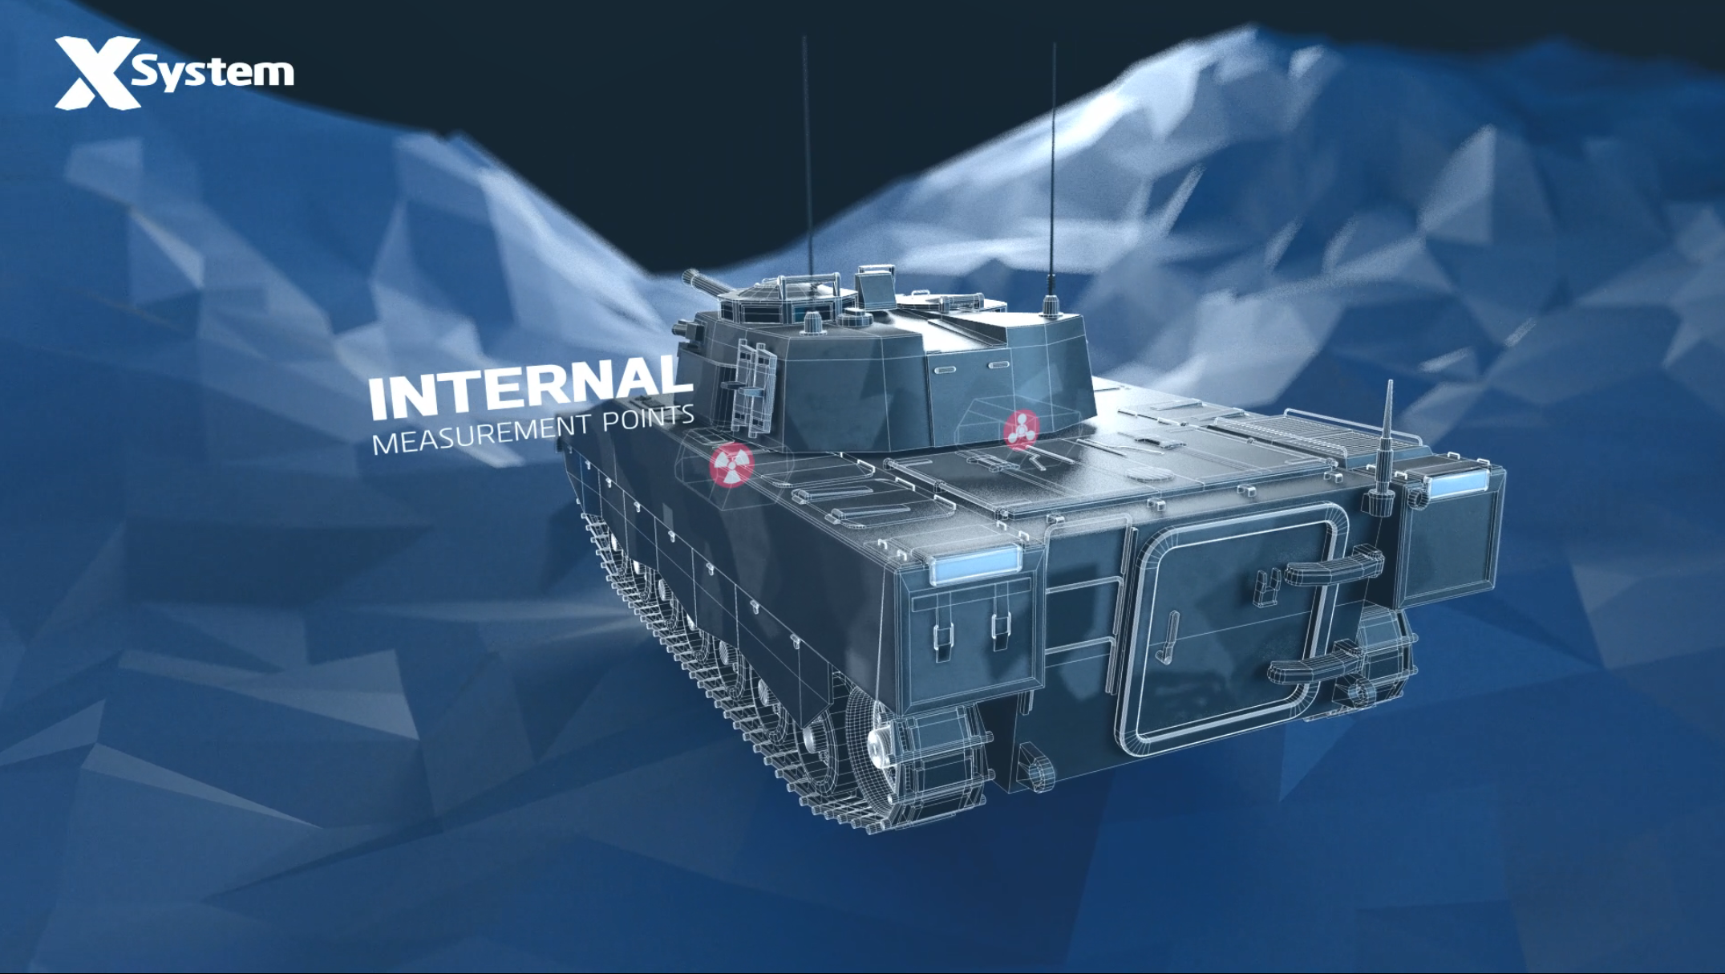
Picture 02 Video still frame from X-System Armoured CBRN Monitoring Application promotional video available in Environics website here https://environics.fi/cbrn-solutions/armoured-cbrn-monitoring/

Picture 03 Video still frame from X-System Naval & Maritime CBRN Monitoring Application promotional video available in Environics website here https://environics.fi/cbrn-solutions/naval-maritime-cbrn-monitoring/

